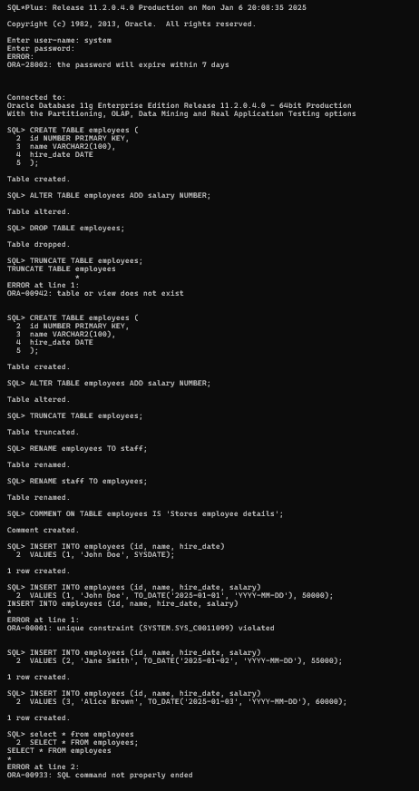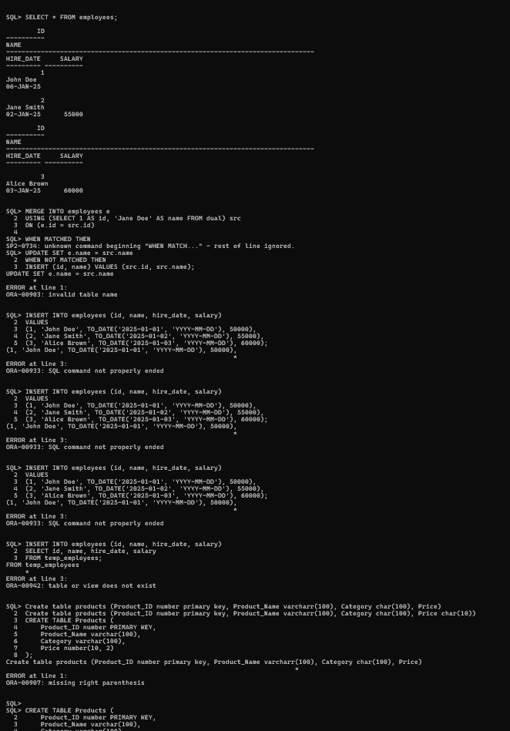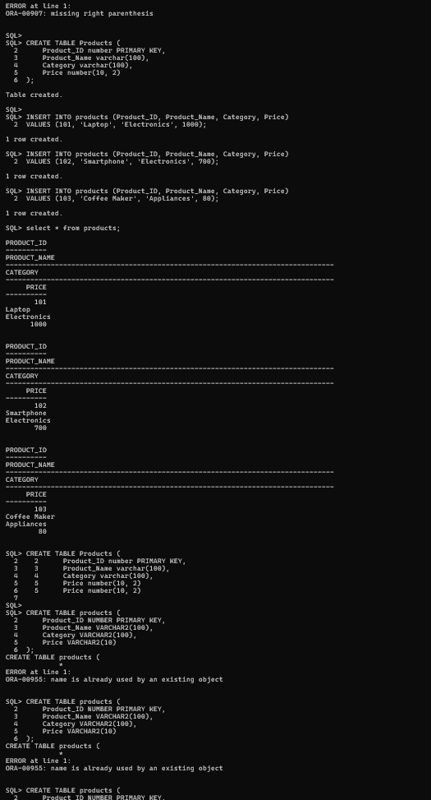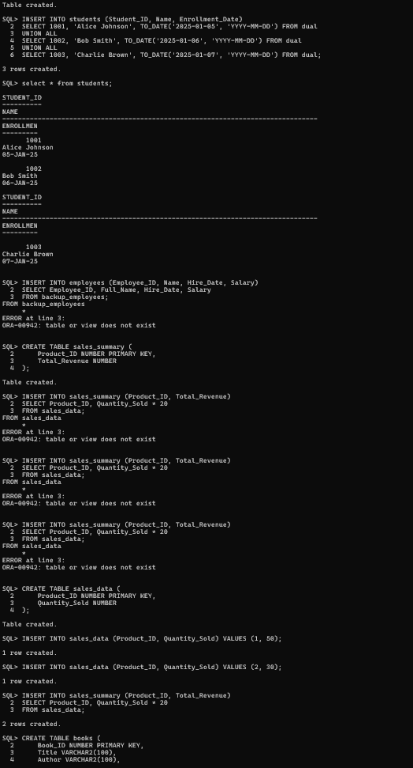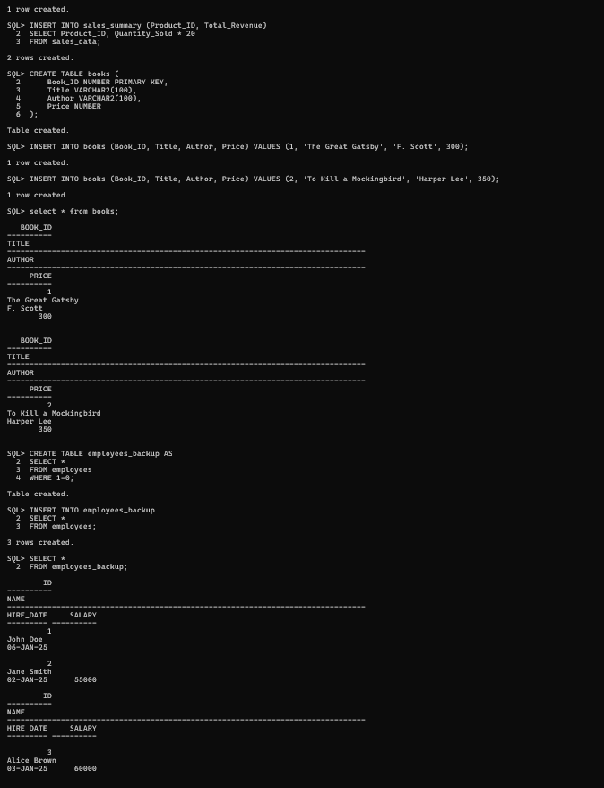

SQL*Plus: Release 11.2.0.4.0 Production on Mon Jan 6 20:08:35 2025

Copyright (c) 1982, 2013, Oracle. All rights reserved.

Enter user-name: system

Enter password:

ERROR:

ORA-28002: the password will expire within 7 days

Connected to:

Oracle Database 11g Enterprise Edition Release 11.2.0.4.0 - 64bit Production

With the Partitioning, OLAP, Data Mining and Real Application Testing options

SQL> CREATE TABLE employees (

2 id NUMBER PRIMARY KEY,

3 name VARCHAR2(100),

4 hire_date DATE

5 );

Table created.

SQL> ALTER TABLE employees ADD salary NUMBER;

Table altered.

SQL> DROP TABLE employees;

Table dropped.

SQL> TRUNCATE TABLE employees;

TRUNCATE TABLE employees

*

ERROR at line 1:

ORA-00942: table or view does not exist

SQL> CREATE TABLE employees (

2 id NUMBER PRIMARY KEY,

3 name VARCHAR2(100),

4 hire_date DATE

5 );

Table created.

SQL> ALTER TABLE employees ADD salary NUMBER;

Table altered.

SQL> TRUNCATE TABLE employees;

Table truncated.

SQL> RENAME employees TO staff;

Table renamed.

SQL> RENAME staff TO employees;

Table renamed.

SQL> COMMENT ON TABLE employees IS 'Stores employee details';

Comment created.

SQL> INSERT INTO employees (id, name, hire_date)

2 VALUES (1, 'John Doe', SYSDATE);

1 row created.

SQL> INSERT INTO employees (id, name, hire_date, salary)

2 VALUES (1, 'John Doe', TO_DATE('2025-01-01', 'YYYY-MM-DD'), 50000);

INSERT INTO employees (id, name, hire_date, salary)

*

ERROR at line 1:

ORA-00001: unique constraint (SYSTEM.SYS_C0011099) violated

SQL> INSERT INTO employees (id, name, hire_date, salary)

2 VALUES (2, 'Jane Smith', TO_DATE('2025-01-02', 'YYYY-MM-DD'), 55000);

1 row created.

SQL> INSERT INTO employees (id, name, hire_date, salary)

2 VALUES (3, 'Alice Brown', TO_DATE('2025-01-03', 'YYYY-MM-DD'), 60000);

1 row created.

SQL> select * from employees

2 SELECT * FROM employees;

SELECT * FROM employees

*

ERROR at line 2:

ORA-00933: SQL command not properly ended

SQL> SELECT * FROM employees;

ID

----------

NAME

--------------------------------------------------------------------------------

HIRE_DATE SALARY

--------- ----------

1

John Doe

06-JAN-25

2

Jane Smith

02-JAN-25 55000

ID

----------

NAME

--------------------------------------------------------------------------------

HIRE_DATE SALARY

--------- ----------

3

Alice Brown

03-JAN-25 60000

SQL> MERGE INTO employees e

2 USING (SELECT 1 AS id, 'Jane Doe' AS name FROM dual) src

3 ON (e.id = src.id)

4

SQL> WHEN MATCHED THEN

SP2-0734: unknown command beginning "WHEN MATCH..." - rest of line ignored.

SQL> UPDATE SET e.name = src.name

2 WHEN NOT MATCHED THEN

3 INSERT (id, name) VALUES (src.id, src.name);

UPDATE SET e.name = src.name

*

ERROR at line 1:

ORA-00903: invalid table name

SQL> INSERT INTO employees (id, name, hire_date, salary)

2 VALUES

3 (1, 'John Doe', TO_DATE('2025-01-01', 'YYYY-MM-DD'), 50000),

4 (2, 'Jane Smith', TO_DATE('2025-01-02', 'YYYY-MM-DD'), 55000),

5 (3, 'Alice Brown', TO_DATE('2025-01-03', 'YYYY-MM-DD'), 60000);

(1, 'John Doe', TO_DATE('2025-01-01', 'YYYY-MM-DD'), 50000),

*

ERROR at line 3:

ORA-00933: SQL command not properly ended

SQL> INSERT INTO employees (id, name, hire_date, salary)

2 VALUES

3 (1, 'John Doe', TO_DATE('2025-01-01', 'YYYY-MM-DD'), 50000),

4 (2, 'Jane Smith', TO_DATE('2025-01-02', 'YYYY-MM-DD'), 55000),

5 (3, 'Alice Brown', TO_DATE('2025-01-03', 'YYYY-MM-DD'), 60000);

(1, 'John Doe', TO_DATE('2025-01-01', 'YYYY-MM-DD'), 50000),

*

ERROR at line 3:

ORA-00933: SQL command not properly ended

SQL> INSERT INTO employees (id, name, hire_date, salary)

2 VALUES

3 (1, 'John Doe', TO_DATE('2025-01-01', 'YYYY-MM-DD'), 50000),

4 (2, 'Jane Smith', TO_DATE('2025-01-02', 'YYYY-MM-DD'), 55000),

5 (3, 'Alice Brown', TO_DATE('2025-01-03', 'YYYY-MM-DD'), 60000);

(1, 'John Doe', TO_DATE('2025-01-01', 'YYYY-MM-DD'), 50000),

*

ERROR at line 3:

ORA-00933: SQL command not properly ended

SQL> INSERT INTO employees (id, name, hire_date, salary)

2 SELECT id, name, hire_date, salary

3 FROM temp_employees;

FROM temp_employees

*

ERROR at line 3:

ORA-00942: table or view does not exist

SQL> Create table products (Product_ID number primary key, Product_Name varcharr(100), Category char(100), Price)

2 Create table products (Product_ID number primary key, Product_Name varcharr(100), Category char(100), Price char(10))

3 CREATE TABLE Products (

4 Product_ID number PRIMARY KEY,

5 Product_Name varchar(100),

6 Category varchar(100),

7 Price number(10, 2)

8 );

Create table products (Product_ID number primary key, Product_Name varcharr(100), Category char(100), Price)

*

ERROR at line 1:

ORA-00907: missing right parenthesis

SQL>

SQL> CREATE TABLE Products (

2 Product_ID number PRIMARY KEY,

3 Product_Name varchar(100),

4 Category varchar(100),

5 Price number(10, 2)

6 );

Table created.

SQL>

SQL> INSERT INTO products (Product_ID, Product_Name, Category, Price)

2 VALUES (101, 'Laptop', 'Electronics', 1000);

1 row created.

SQL> INSERT INTO products (Product_ID, Product_Name, Category, Price)

2 VALUES (102, 'Smartphone', 'Electronics', 700);

1 row created.

SQL> INSERT INTO products (Product_ID, Product_Name, Category, Price)

2 VALUES (103, 'Coffee Maker', 'Appliances', 80);

1 row created.

SQL> select * from products;

PRODUCT_ID

----------

PRODUCT_NAME

--------------------------------------------------------------------------------

CATEGORY

--------------------------------------------------------------------------------

PRICE

----------

101

Laptop

Electronics

1000

PRODUCT_ID

----------

PRODUCT_NAME

--------------------------------------------------------------------------------

CATEGORY

--------------------------------------------------------------------------------

PRICE

----------

102

Smartphone

Electronics

700

PRODUCT_ID

----------

PRODUCT_NAME

--------------------------------------------------------------------------------

CATEGORY

--------------------------------------------------------------------------------

PRICE

----------

103

Coffee Maker

Appliances

80

SQL> CREATE TABLE Products (

2 2 Product_ID number PRIMARY KEY,

3 3 Product_Name varchar(100),

4 4 Category varchar(100),

5 5 Price number(10, 2)

6 5 Price number(10, 2)

7

SQL>

SQL> CREATE TABLE products (

2 Product_ID NUMBER PRIMARY KEY,

3 Product_Name VARCHAR2(100),

4 Category VARCHAR2(100),

5 Price VARCHAR2(10)

6 );

CREATE TABLE products (

*

ERROR at line 1:

ORA-00955: name is already used by an existing object

SQL> CREATE TABLE products (

2 Product_ID NUMBER PRIMARY KEY,

3 Product_Name VARCHAR2(100),

4 Category VARCHAR2(100),

5 Price VARCHAR2(10)

6 );

CREATE TABLE products (

*

ERROR at line 1:

ORA-00955: name is already used by an existing object

SQL> CREATE TABLE products (

2 Product_ID NUMBER PRIMARY KEY,

3 Product_Name VARCHAR2(100),

4 Category VARCHAR2(100),

5 Price VARCHAR2(10)

6 );

CREATE TABLE products (

*

ERROR at line 1:

ORA-00955: name is already used by an existing object

SQL> CREATE TABLE students (

2 Student_ID NUMBER PRIMARY KEY,

3 Name VARCHAR2(100),

4 Enrollment_Date DATE

5 );

Table created.

SQL> INSERT INTO students (Student_ID, Name, Enrollment_Date)

2 SELECT 1001, 'Alice Johnson', TO_DATE('2025-01-05', 'YYYY-MM-DD') FROM dual

3 UNION ALL

4 SELECT 1002, 'Bob Smith', TO_DATE('2025-01-06', 'YYYY-MM-DD') FROM dual

5 UNION ALL

6 SELECT 1003, 'Charlie Brown', TO_DATE('2025-01-07', 'YYYY-MM-DD') FROM dual;

3 rows created.

SQL> select * from students;

STUDENT_ID

----------

NAME

--------------------------------------------------------------------------------

ENROLLMEN

---------

1001

Alice Johnson

05-JAN-25

1002

Bob Smith

06-JAN-25

STUDENT_ID

----------

NAME

--------------------------------------------------------------------------------

ENROLLMEN

---------

1003

Charlie Brown

07-JAN-25

SQL> INSERT INTO employees (Employee_ID, Name, Hire_Date, Salary)

2 SELECT Employee_ID, Full_Name, Hire_Date, Salary

3 FROM backup_employees;

FROM backup_employees

*

ERROR at line 3:

ORA-00942: table or view does not exist

SQL> CREATE TABLE sales_summary (

2 Product_ID NUMBER PRIMARY KEY,

3 Total_Revenue NUMBER

4 );

Table created.

SQL> INSERT INTO sales_summary (Product_ID, Total_Revenue)

2 SELECT Product_ID, Quantity_Sold * 20

3 FROM sales_data;

FROM sales_data

*

ERROR at line 3:

ORA-00942: table or view does not exist

SQL> INSERT INTO sales_summary (Product_ID, Total_Revenue)

2 SELECT Product_ID, Quantity_Sold * 20

3 FROM sales_data;

FROM sales_data

*

ERROR at line 3:

ORA-00942: table or view does not exist

SQL> INSERT INTO sales_summary (Product_ID, Total_Revenue)

2 SELECT Product_ID, Quantity_Sold * 20

3 FROM sales_data;

FROM sales_data

*

ERROR at line 3:

ORA-00942: table or view does not exist

SQL> CREATE TABLE sales_data (

2 Product_ID NUMBER PRIMARY KEY,

3 Quantity_Sold NUMBER

4 );

Table created.

SQL> INSERT INTO sales_data (Product_ID, Quantity_Sold) VALUES (1, 50);

1 row created.

SQL> INSERT INTO sales_data (Product_ID, Quantity_Sold) VALUES (2, 30);

1 row created.

SQL> INSERT INTO sales_summary (Product_ID, Total_Revenue)

2 SELECT Product_ID, Quantity_Sold * 20

3 FROM sales_data;

2 rows created.

SQL> CREATE TABLE books (

2 Book_ID NUMBER PRIMARY KEY,

3 Title VARCHAR2(100),

4 Author VARCHAR2(100),

5 Price NUMBER

6 );

Table created.

SQL> INSERT INTO books (Book_ID, Title, Author, Price) VALUES (1, 'The Great Gatsby', 'F. Scott', 300);

1 row created.

SQL> INSERT INTO books (Book_ID, Title, Author, Price) VALUES (2, 'To Kill a Mockingbird', 'Harper Lee', 350);

1 row created.

SQL> select * from books;

BOOK_ID

----------

TITLE

--------------------------------------------------------------------------------

AUTHOR

--------------------------------------------------------------------------------

PRICE

----------

1

The Great Gatsby

F. Scott

300

BOOK_ID

----------

TITLE

--------------------------------------------------------------------------------

AUTHOR

--------------------------------------------------------------------------------

PRICE

----------

2

To Kill a Mockingbird

Harper Lee

350

SQL> CREATE TABLE employees_backup AS

2 SELECT *

3 FROM employees

4 WHERE 1=0;

Table created.

SQL> INSERT INTO employees_backup

2 SELECT *

3 FROM employees;

3 rows created.

SQL> SELECT *

2 FROM employees_backup;

ID

----------

NAME

--------------------------------------------------------------------------------

HIRE_DATE SALARY

--------- ----------

1

John Doe

06-JAN-25

2

Jane Smith

02-JAN-25 55000

ID

----------

NAME

--------------------------------------------------------------------------------

HIRE_DATE SALARY

--------- ----------

3

Alice Brown

03-JAN-25 60000

SQL>